**Snapshots of results:**

MySQL Workbench was used to complete the Assignment and to retrieve the expected results using queries.

1. Retrieve the list of countries that have won a world cup.

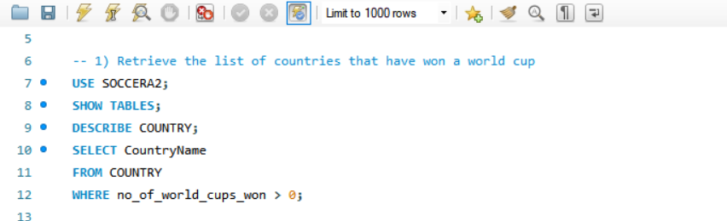

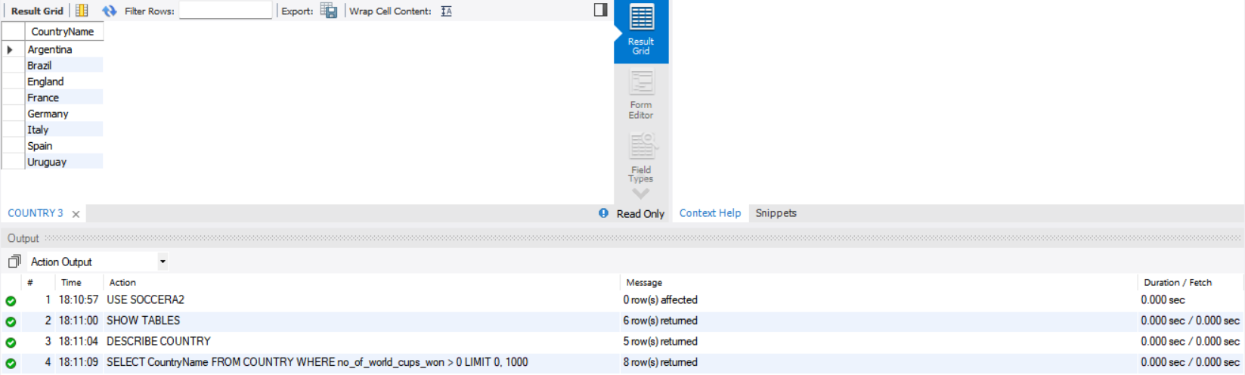



No of Rows or records returned is 8

1. Retrieve the list of country names that have won a world cup and the number of  world cups each has won in descending order.

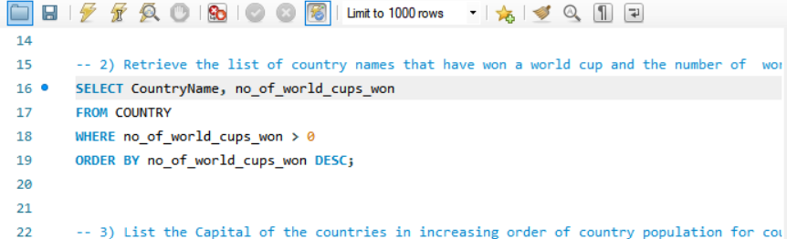

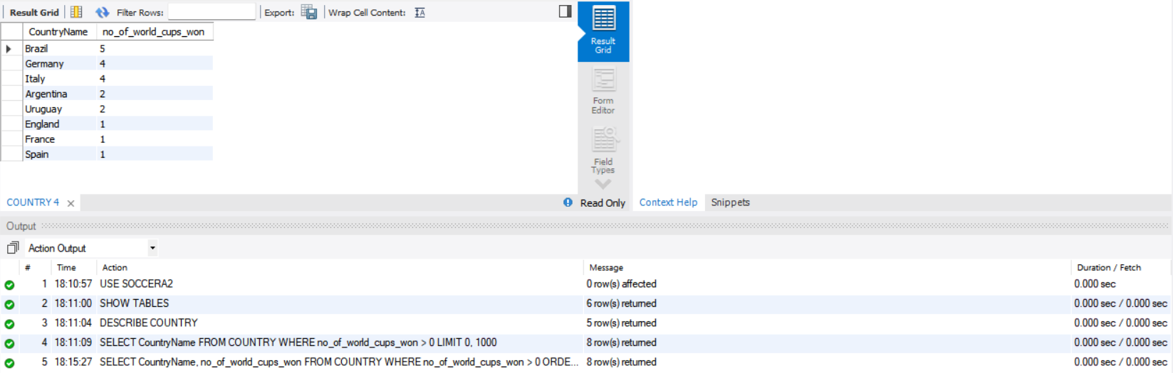

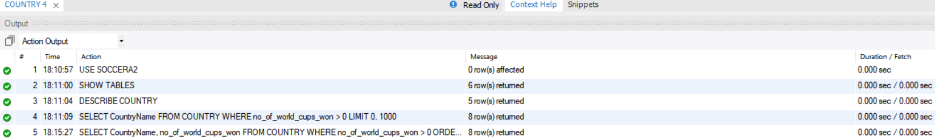

No of Rows or records returned is 8

1. List the Capital of the countries in increasing order of country population for countries that have population more than 100 million.

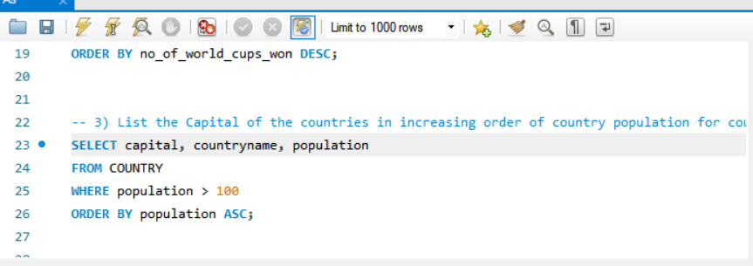

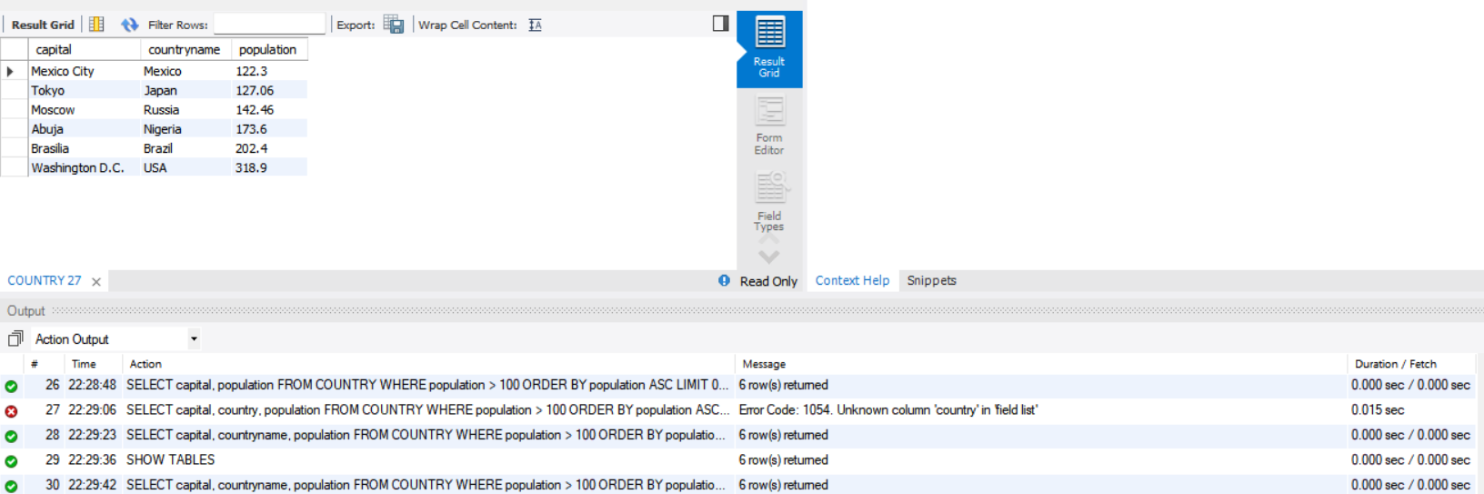

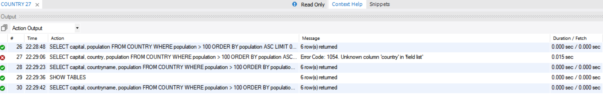

No of Rows or records returned is 6

1. List the Name of the stadium which has hosted a match where the number of goals scored by a single team was greater than 4.

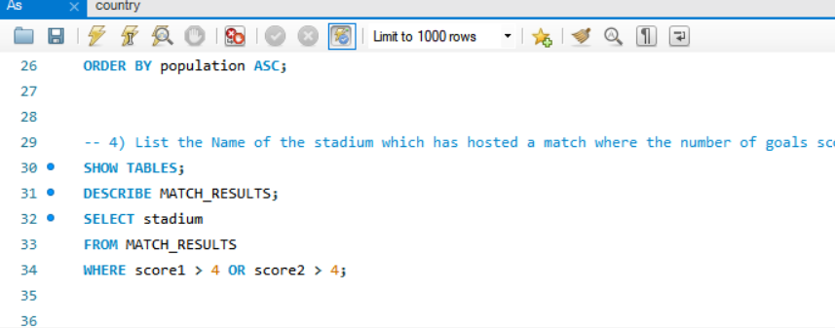

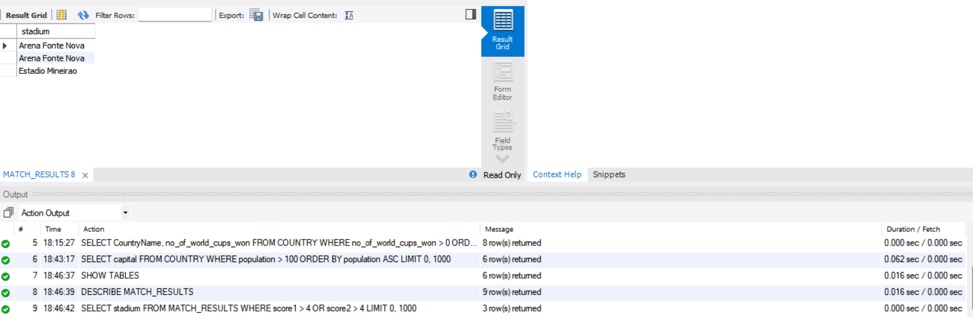

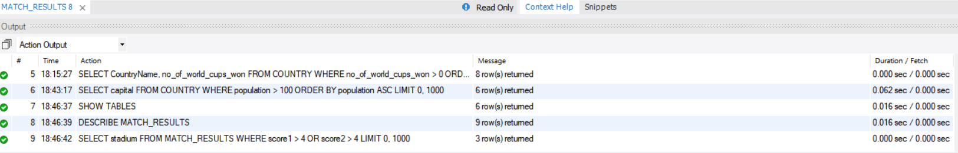

No of Rows or records returned is 3

With select Distinct to only select unique Stadium names we use Distinct and in this case we get only 2 returned records

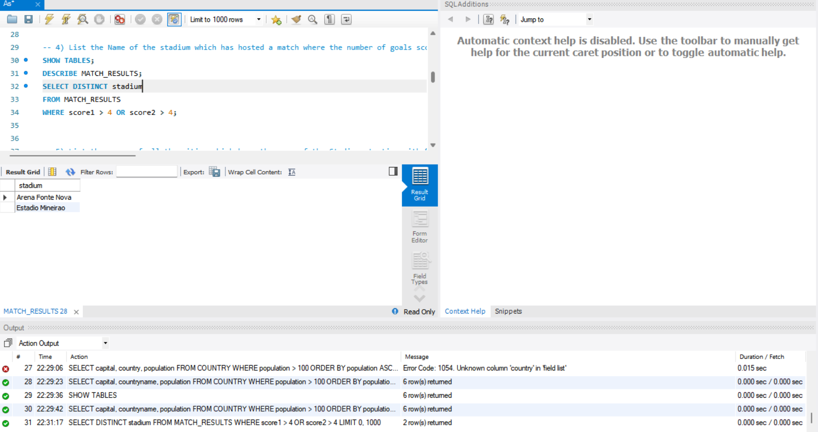

1. List the names of all the cities which have the name of the Stadium starting with “Estadio”.

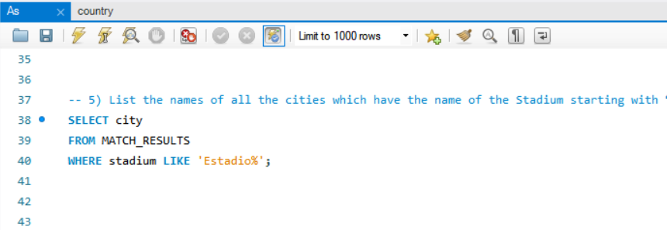

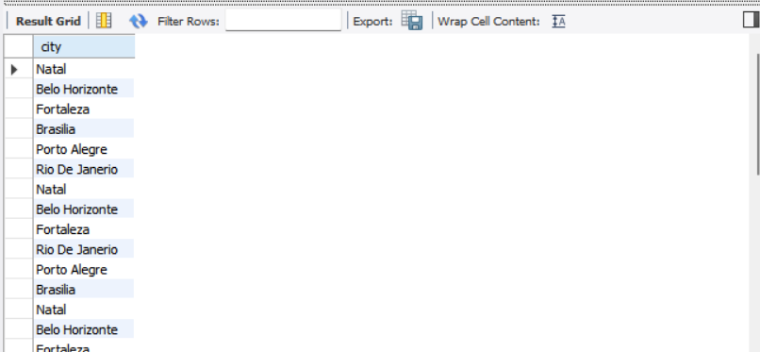

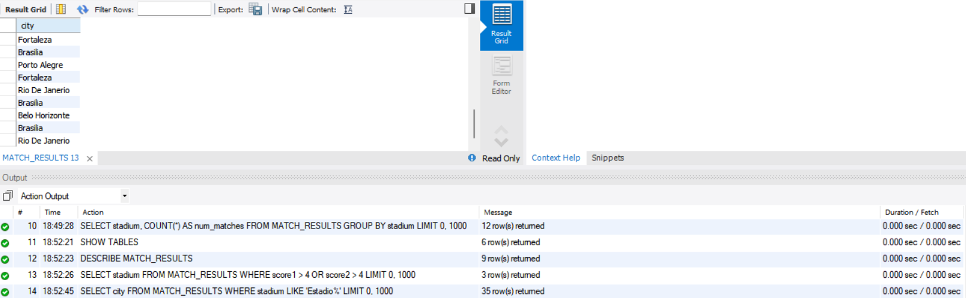

No of Rows or records returned is 35

To only select unique city names, we use keyword Distinct and here in this case we only get 6 rows.

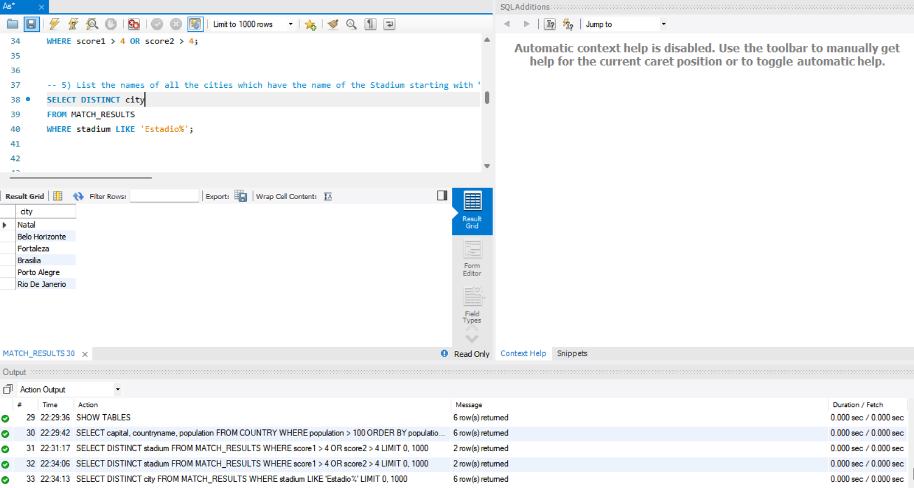

1. List all stadiums and the number of matches hosted by each stadium.

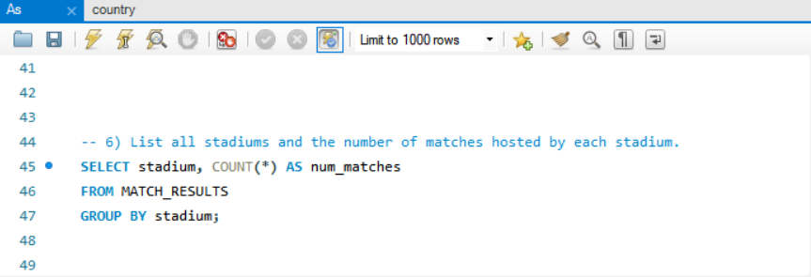

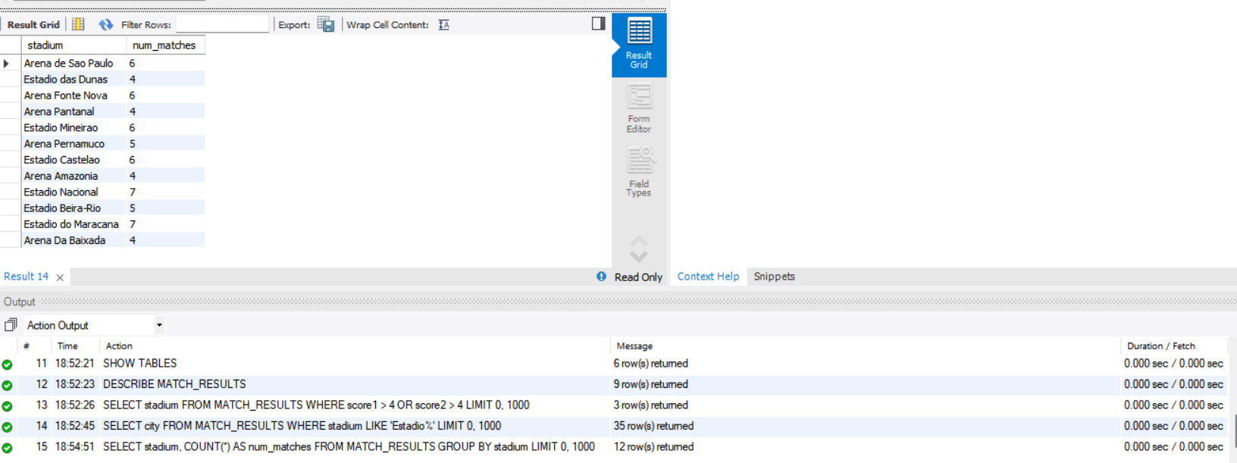

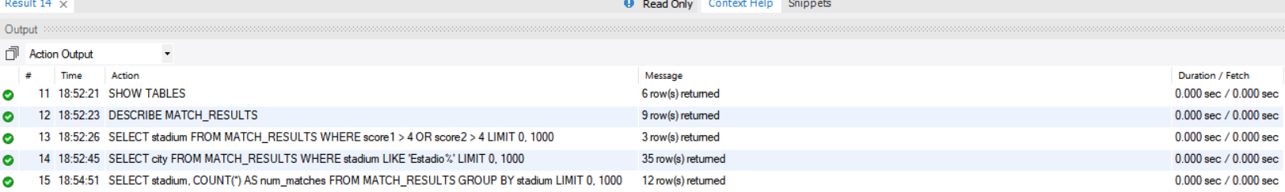

No of Rows or records returned is 12

1. List the First Name, Last Name and Date of Birth of Players whose heights is greater than 198 cms.

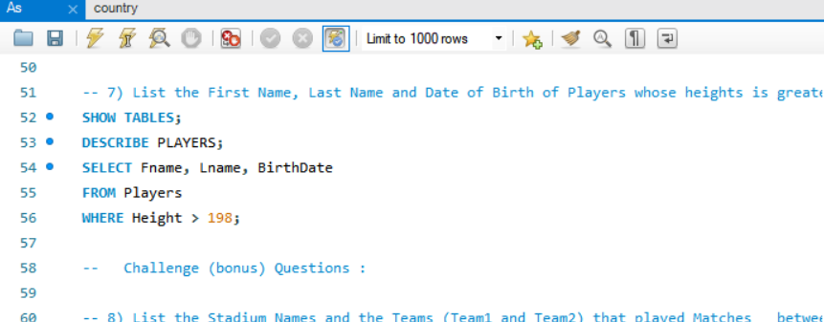

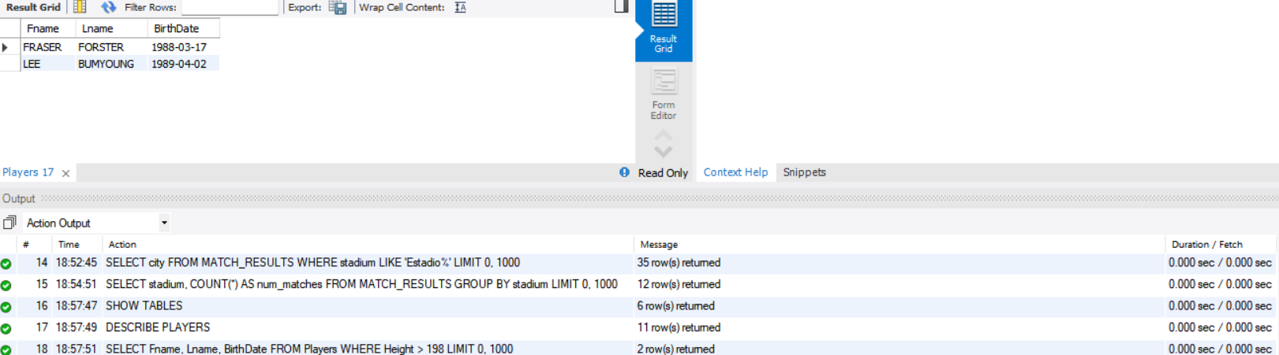

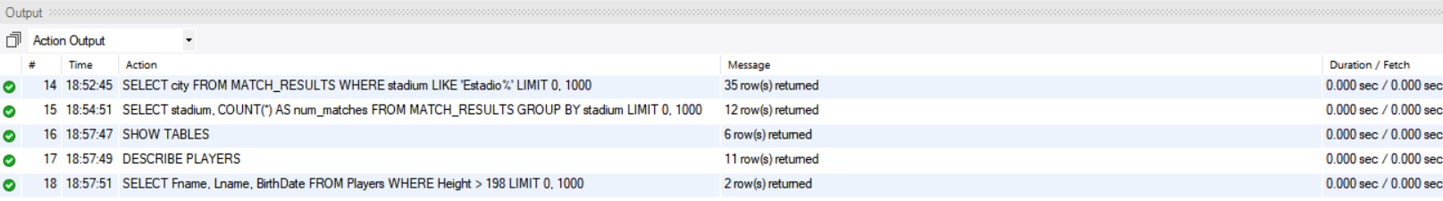

No of Rows or records returned is 2

**Bonus Questions**

8. List the Stadium Names and the Teams (Team1 and Team2) that played Matches   between 20-Jun-2014 and 24-Jun-2014

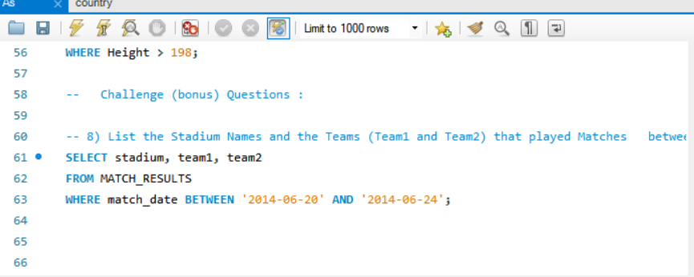

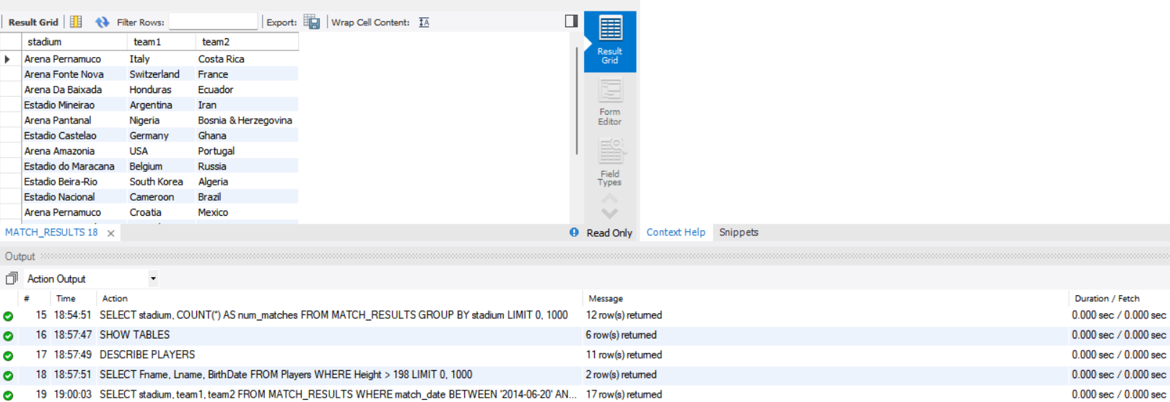

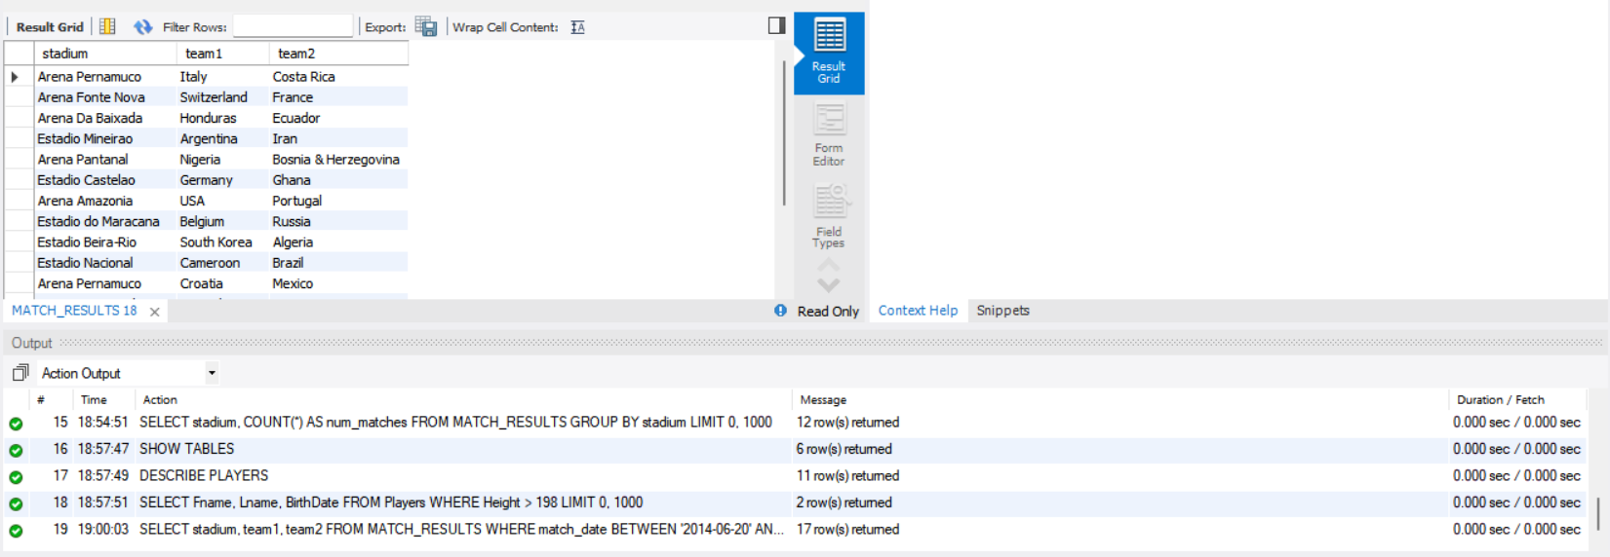

No of Rows or records returned is 17

  9. List the Fname, Lname, Position and No of Goals scored by the **Captain** of a team  who has more than 2 Yellow cards or 1 Red card .

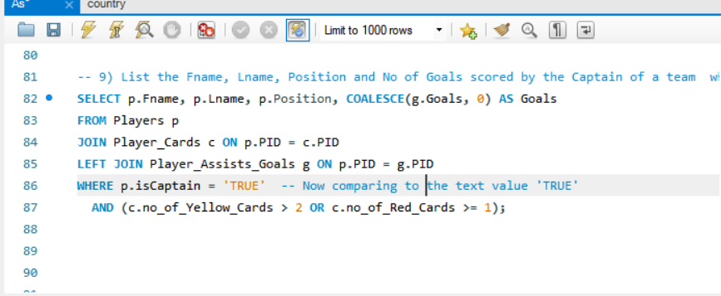

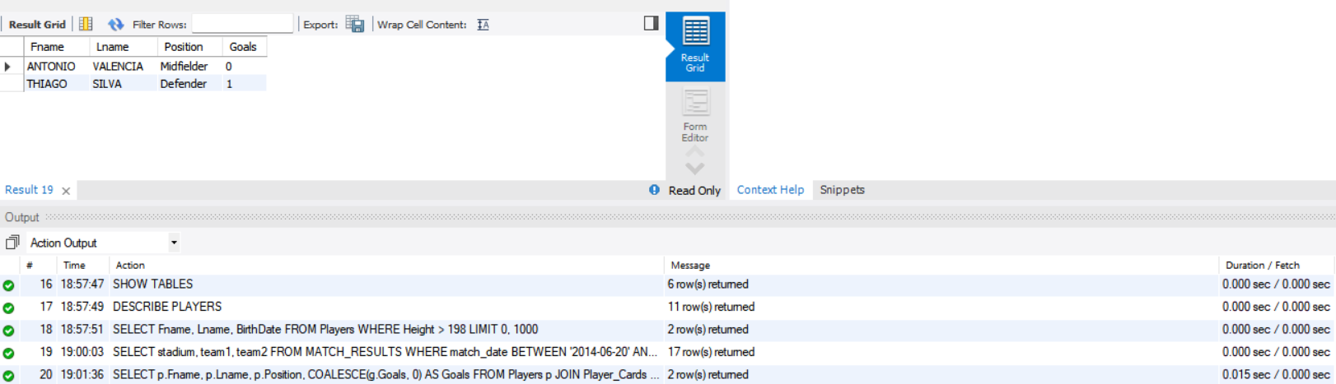

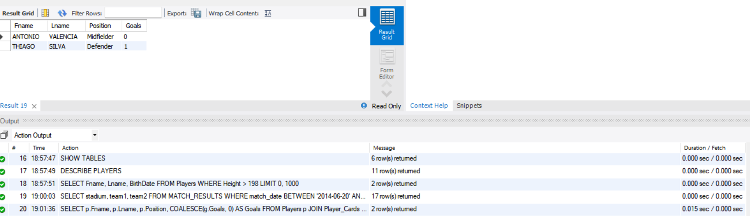

No of Rows or records returned is 2

Here in this case when we use Describe Table Players we get the isCaptain field as Text hence we use ‘TRUE’ String to get required output. Only by using True we don’t get any rows returned.